**Chapter 7 Positioning**

|  |
| --- |
| 7.1 Introduction 7.2 Faceting 7.3 Co-ordinate Systems |

* Faceting seems to permit different scales for different facets.
* Setting scales using ggplot2.

|  |
| --- |
| 1. Facet grid 2. Facet wrap 3. Controlling scales 4. Missing faceting variables 5. Grouping vs faceting 6. Dodging vs. faceting 7. Continuous variables |

**7.2.1 Facet Grid**

* Removes 29 cars from the data set.

|  |
| --- |
| > dim(mpg)  [1] 234 11  > Mpg2 <- subset(mpg, cyl != 5 & drv %in% c("4","f"))  > dim(Mpg2)  [1] 205 11 |

|  |
| --- |
| qplot(cty,hwy,data=Mpg2) + facet_grid(.~ cyl) |

facet_grid(cyl ~ .) :More or less the same graph, but on top of each other.

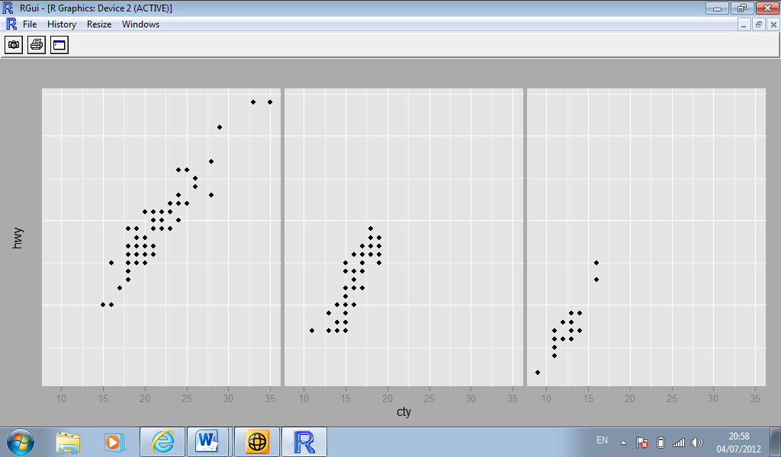

|  |
| --- |
| qplot(cty,data=Mpg2,geom="histogram",binwidth=2) + facet_grid(cyl ~ .) |

|  |
| --- |
| > qplot(cty,data=Mpg2,geom="histogram",binwidth=2)  + facet_grid(cyl ~ drv) |

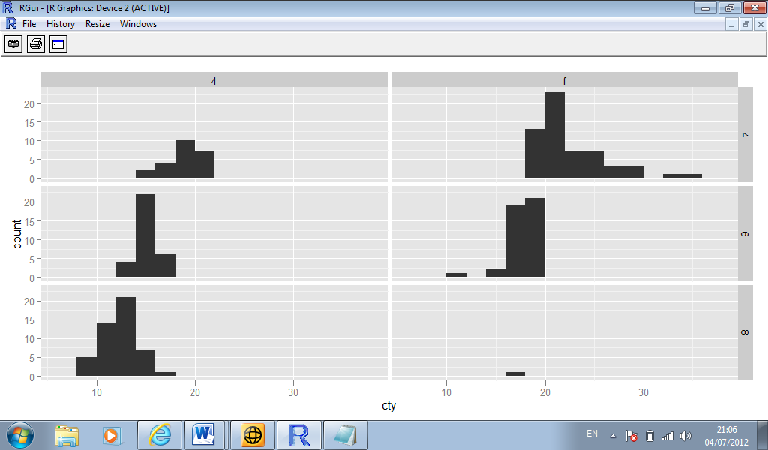

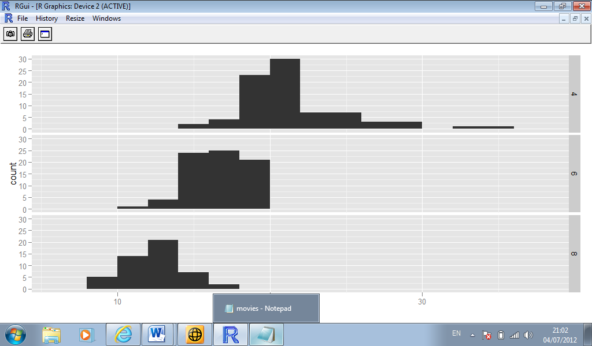

Margins

Faceting a plot is like creating a contingency table. It is often useful to display marginal totals as well the individual cells

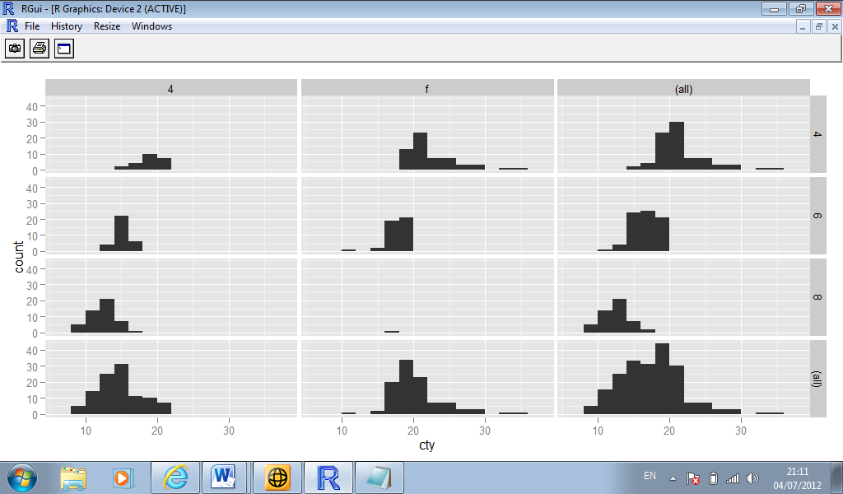

**7.2.2. Facet Wrap**

* An alternative to the grid is a wrapped ribbon of plots,
* facet_wrap generates a long ribbon of plots, and wraps it into 2d.

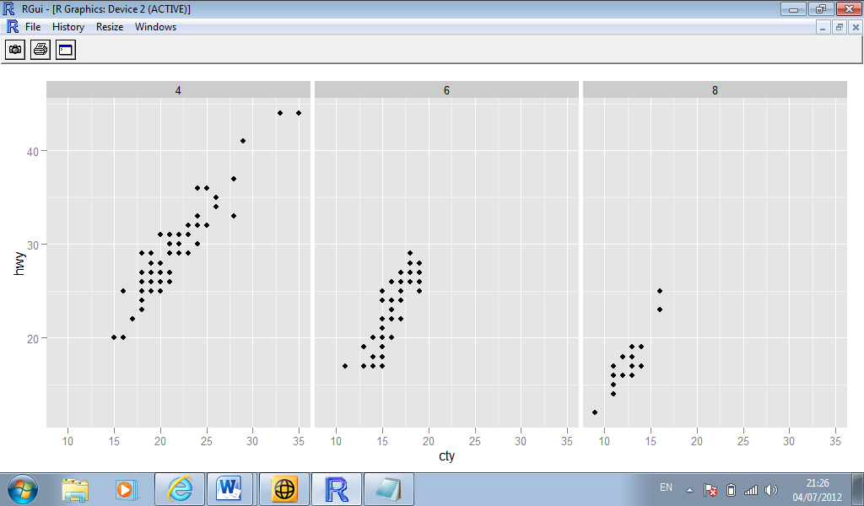

**7.2.3 Controlling scales**

* For both types of faceting you can control whether or not the position scales are the same in all panels, or allowed to vary (i.e. are the scales “fixed” or “free”?)
* Fixed allows for us to compare subsets on an equal basis. It is the default setting.
* Free allows us to examine each panel at the appropriate level of detail.
* To specify “free” scaling, we add the phrase “scales = free” to the facet_grid() or facet_wrap() commands.

|  |
| --- |
| > qplot(cty,data=Mpg2,geom="histogram",binwidth=2) + facet_grid(cyl ~ .,scales = "free") |

7.2.5

Faceting is an alternative to using aesthetics (size,colour, shape) to differentiate groups.

**7.3 co-ordinate systems**

(not in class)

|  |
| --- |
| 1. Transformations 2. Statistics 3. Cartesian co-ordinate systems 4. Non-Cartesian co-ordinate systems |

**7.3.2 Statistics**  
  
The actual statistical method used by a stat should depend on the co-ordinate system  
  
**7.3.4 Non-Cartesian co-ordinate systems**  
  
**Polar co-ordinates**

* The theta argument determines which position variable is mapped to angle (by default, x) and which to radius

**Map Projections**

* rely on the ***mapproj*** package